

J.E. CAIRNES SCHOOL OF BUSINESS & ECONOMICS

Module Code | MS5107
Student Name and ID | 24236930

In submitting this assignment, I am aware that it is my responsibility to adhere to the submission guidelines. Please tick (double click… or Yes/No) for the following:

 | Yes | No
I am aware of what the University of Galway plagiarism policy entails.
I have named the assignment file (MS Word docx , doc, or xlsx ) to contain my student ID and the module code and assignment number (e.g., 1187404_MS5107_A1.docx or 1187404_MS5107_A1.xlsx).

Declaration for this Assignment Submission:
- In submitting this work I confirm that it is entirely my own. I acknowledge that I may be invited to interview if there is any concern in relation to the integrity, and I am aware that any breach will be subject to the University's Procedures for dealing with plagiarism (QA220 Academic Integrity Policy and Appendix:
https://www.universityofgalway.ie/media/registrar/policiesmay2023/QA220-Academic-Integrity-Policy-v2.0-Sept-2023.pdf
https://www.universityofgalway.ie/media/registrar/policiesmay2023/Appendix-1-QA220-Academic-Integrity-Policy-v2.0-Sept-2023.pdf ).

ASSIGNMENT REPORT

Objective:
The objective of the problem is to maximise the profit of a brewery by determining the optimal production in litres of different types of beer (light beer, lager, and ale).

Formulation

Decision Variables:
- X1​: Light beer produced (in litres)
- X2​: Lager produced (in litres)
- X3​: Ale produced (in litres)
- A: Number of cans
- B: Number of bottles

Objective Function:
Maximize(11.5*X1​+12.3*X2​+13.8*X3-1400​)
(where: €11.5, €12.3, and €13.8 are the profit per litre of Light beer, Lager and Ale respectively, and €1400 is The fixed cost for security, rent, and taxes.)

Constraints:

- Resource Constraints (in grams)
  - Hops: 9*X1 ​+ 7*X2 ​+ 6*X3 ​≤ 20000
  - Yeast: 8*X1​ + 8*X2 ​+ 8*X3 ​≤ 18000
  - Barley: 60*X1 ​+ 120*X2 ​+ 100*X3 ​≤ 190000

- Time Constraints (in seconds)
  - Brewing Time: 225*X1 ​+ 330*X2 ​+ 405*X3 ​≤ 720000
  - Packaging Time: 30*A + 45*B ≤ 360000

- Storage Constraints (no. of units)
  - Cans Capacity: A ≤ 4000
  - Bottles Capacity: B ≤ 8000
  - Cans and Bottles Relation: A ​≤ 2/3(B)
  - Total Cans and Bottles: A + B = 2*(X1 + X2 + X3)

Solution Using Solver

- X1​ (Pale Ale): 1062.5 litres
- X2​ (Lager): 0 litres
- X3​ (Stout): 1187.5 litres
- A (Cans): 1800
- B (Bottles): 2700
- Total Profit: €27206.25

The MS Excel file containing the model is attached.

Scenario Analysis

- Increase in Cost of Lager Production by 35 cents per litre
- Since the reduced cost for X2​ is -0.5417, in the current optimal solution we are not producing Lager (indicating it is not profitable in the current solution), so this increase would have no impact on the current solution.
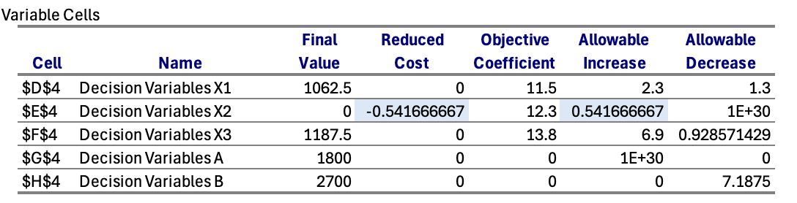

b) Purchase of Additional Yeast at 20 Cents per Gram
- Currently, yeast is fully utilized with a shadow price of €1.0781, meaning each additional gram of yeast could increase profit by €1.0781.
- The brewery should buy the additional 1.2 kg (1200 grams) of yeast, as it is in the allowable increase range 2078.431373 for the current optimal solution, and the profit would be increased by 88 cents per gram, as the profit(1.08 per gram) outweighs the cost (0.20 per gram).
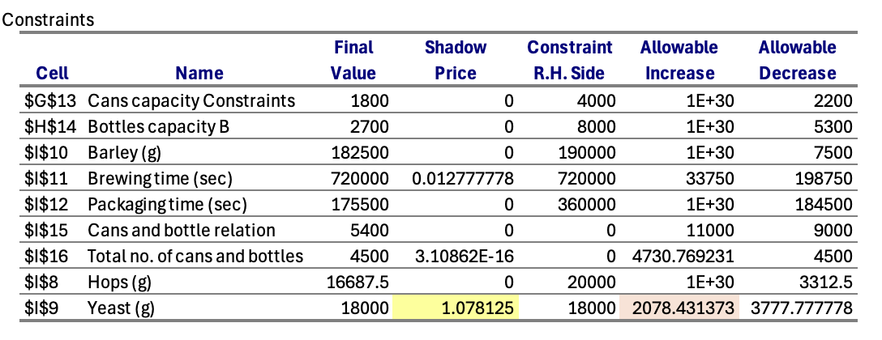

c) Overtime for Workers
- The shadow price for packaging time is 0, and slack of 184500 seconds, which means works are have more time than needed, so it make no sense for allowing the workers to work extra hours for packaging.
- The shadow price for brewing time is 0.0128, meaning each extra second of brewing time could add 0.0128 to the profit (which is €46.08 per hour).
- So, if the cost of overtime is lower than the profit gained (based on €46.08 per hour), allowing overtime would be beneficial. Otherwise, it should be avoided.
- As the allowable increase is 33750 sec (9.375 hours) it is the maximum time works can overtime for this optimal solution.
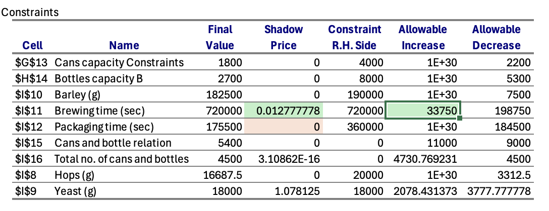

d) Drone Delivery of 10 kg of Additional Resources
- As yeast has the highest shadow price, adding extra yeast would likely increase profit most. The allowable increase for yeast is 2078.431373 grams (for current optimal solution, if its added in more quantity the optimal solution will be changed), Management should consider adding yeast(around 2 Kg), as additional yeast would yield the greatest immediate benefit.
- Other two resources can be added as well if needed (but will have no impact on profit as their shadow price is 0 and allowable increase is infinity).
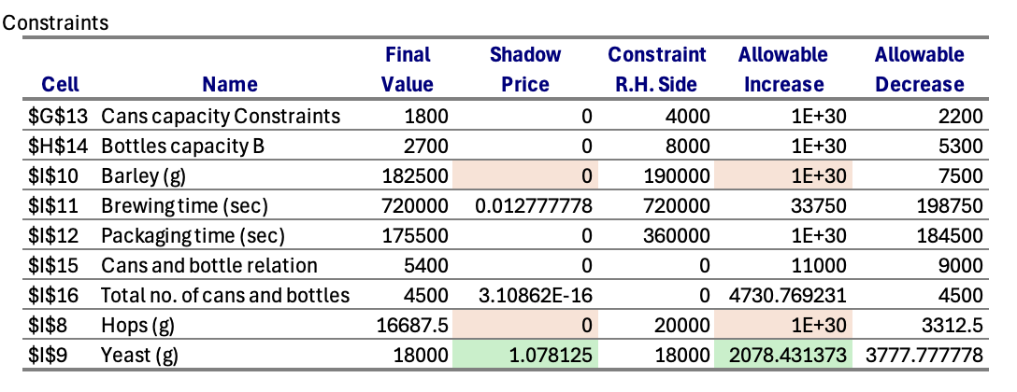
e) Conditions to Start Producing Lager
- For lager currently production is zero, to produce Lager and become profitable, either the cost of production should decrease by €0.54(or more), or price per litre have to be increased by €0.54(or more).

